CS 255 System Design Document Template

UML Diagrams

UML Use Case Diagram
[In Module Six, you were asked to complete a use case diagram based on your system design. If you would like to make any adjustments to your diagram, please do so. Please insert your use case diagram here. Check to make sure that you included appropriate components and symbols and that your design meets the client’s needs.]
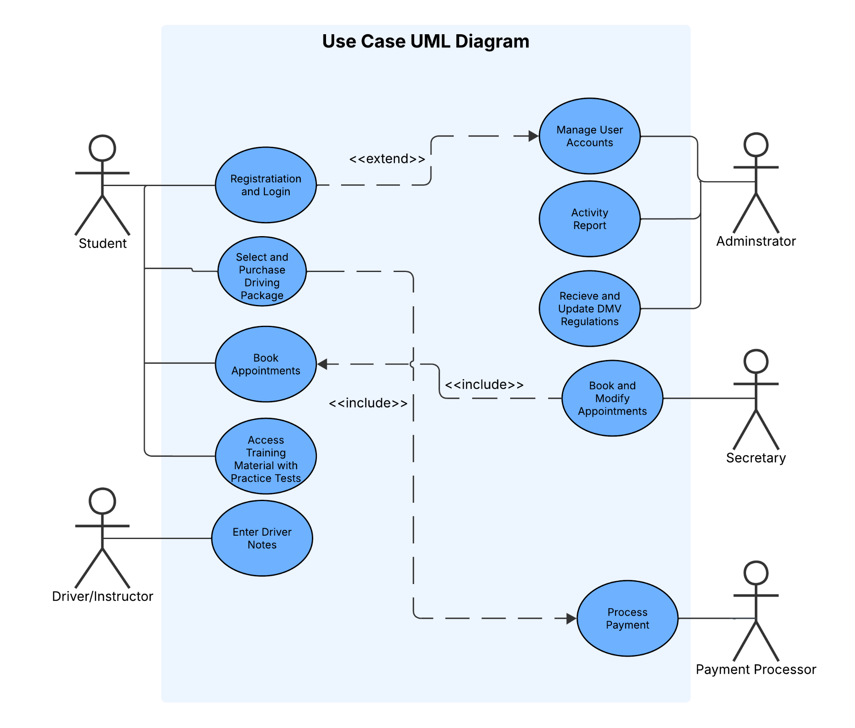

UML Activity Diagrams
[You were asked to choose two use cases and create two activity diagrams, one for each use case. Please insert both of your activity diagrams here. Check to make sure that you included appropriate components and symbols and that your design meets the client’s needs.]
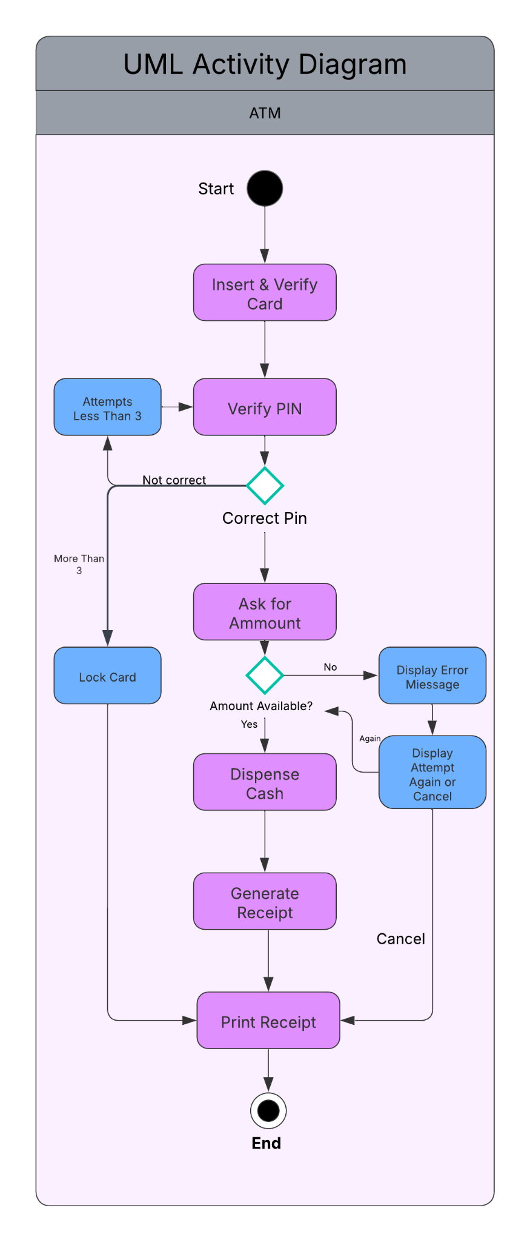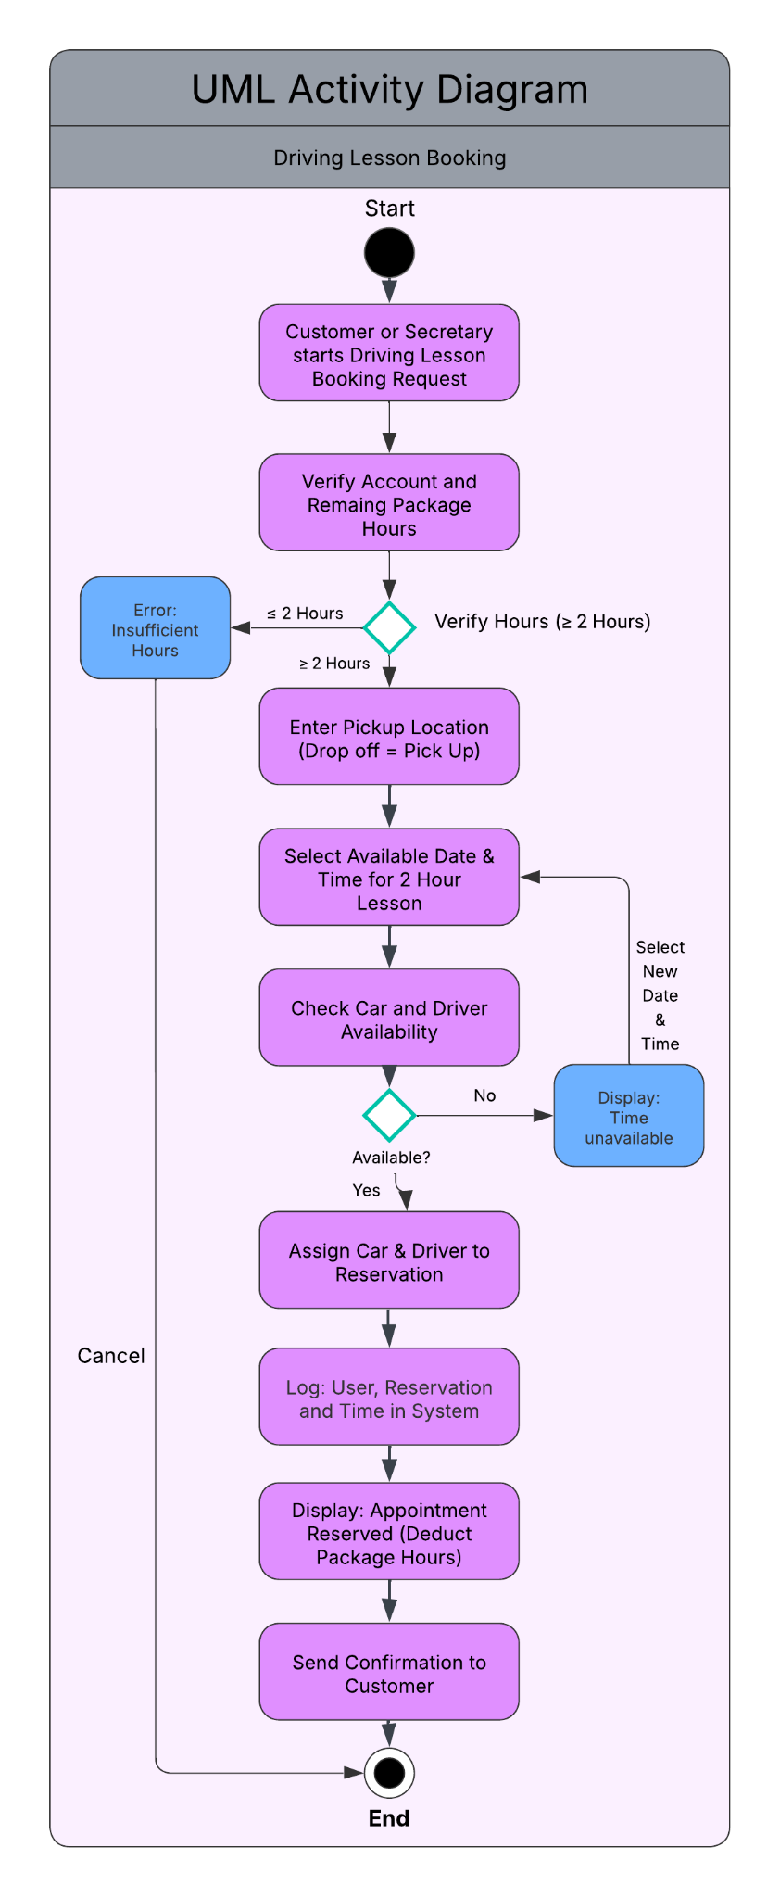

UML Sequence Diagram
[You were asked to create a sequence diagram based on one of the use cases you chose. Please insert your sequence diagram here. Check to make sure that you included appropriate components and symbols and that your design meets the client’s needs.]
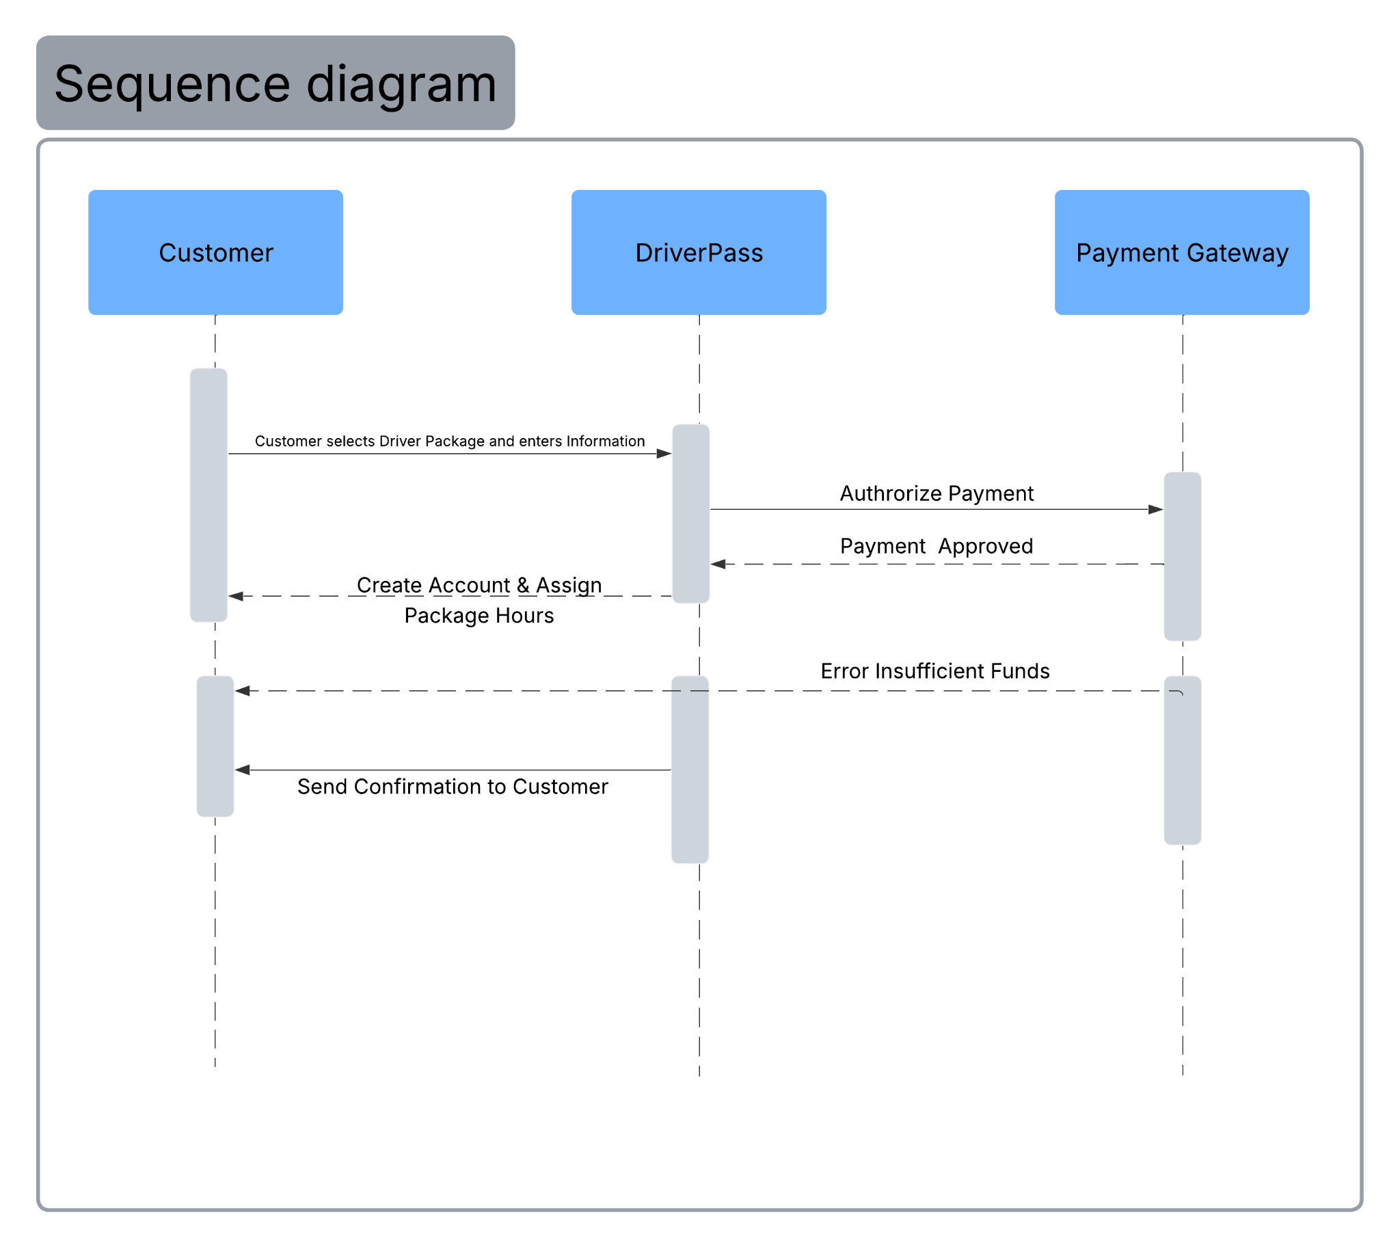

UML Class Diagram
[You were asked to create a class diagram based on the different classes and attributes needed for your system design. You are not required to include methods, but you may if you wish. Please insert your class diagram here. Check to make sure that you included appropriate components and symbols and that your design meets the client’s requirements.]
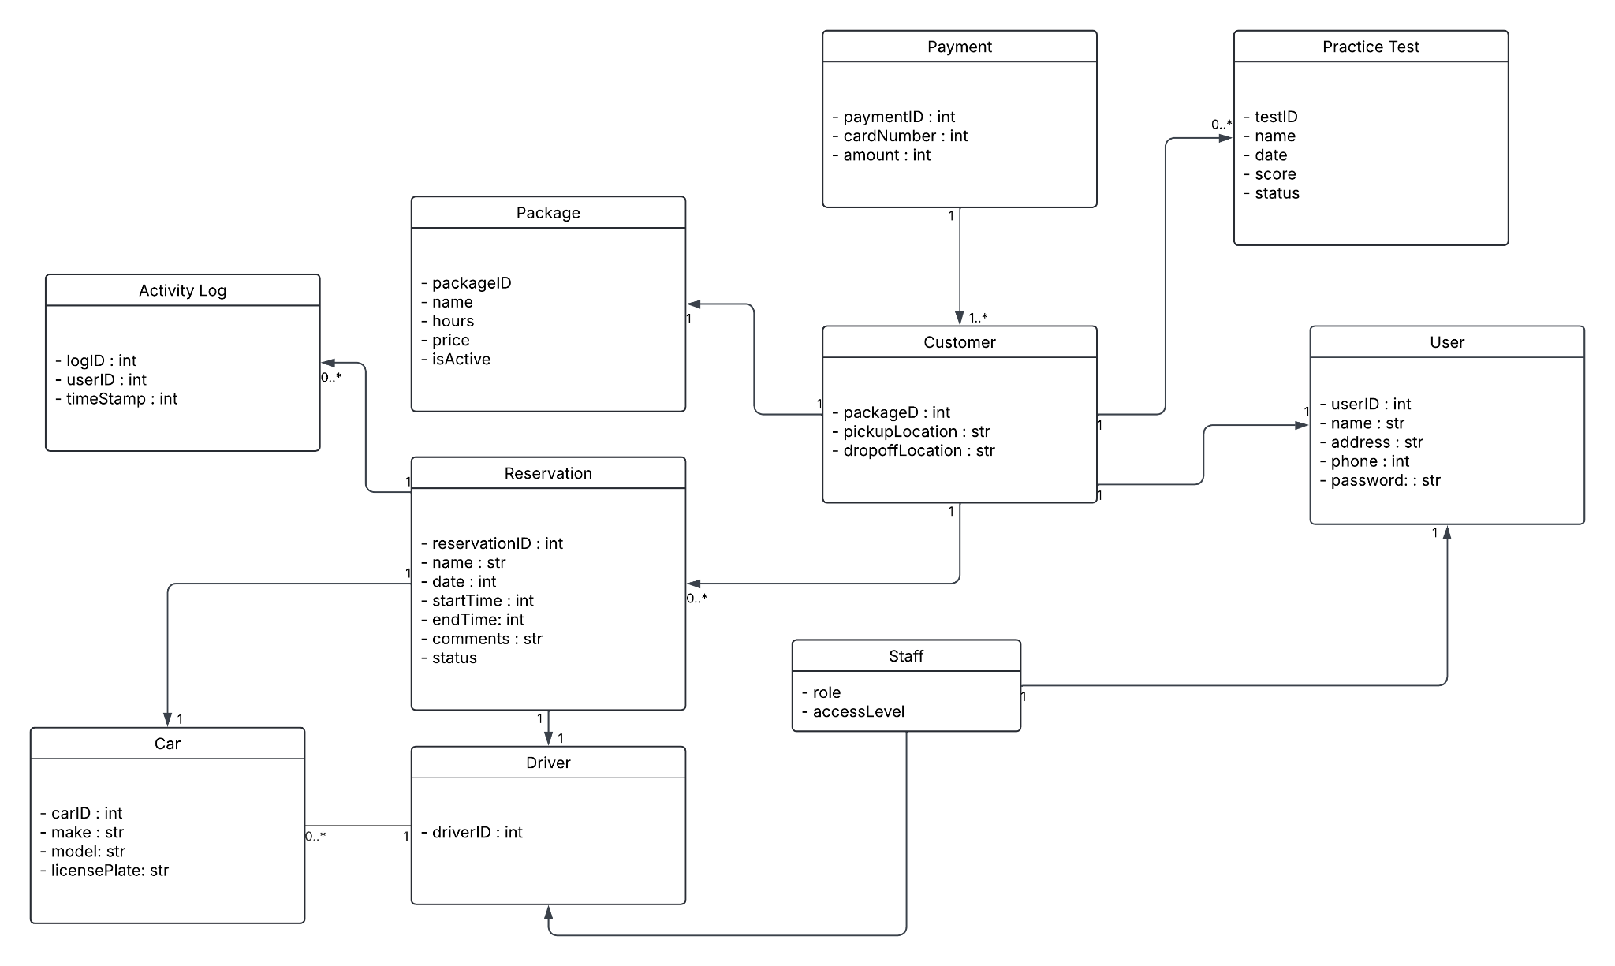

Technical Requirements
[Based on the diagrams you have created, describe the technical requirements of your system. These requirements should address the required hardware, software, tools, and infrastructure necessary for your system design.]

The DriverPass system as whole requires a cloud-hosted (AWS/Azure), web-based platform with multiplatform access to a variety of devices such as desktops, tablets and smartphones through modern browsers. A backend framework (Java based) to support Account Management and Logins with a relational database like MySQL to store information such as Customer personal information and Car/Driver details. The system also has a way to track test progress and driver notes. A third party Payment gateway is also included to purchase driver packages and to not store sensitive payment information. The website is accessed and encrypted with HTTPS/TLS encryption to ensure safe security practices and enforced role-based permissions that distinguishes access based on roles. Other security measures such as suspicious activity and brute force login detection is also implemented. A scheduled DMV data feed that keeps practice tests and current rules and regulations updated for the Users with automatic updates.

